BENCH & BAR TENNIS DAY 2022

DATE: Wednesday 21 December 2022  VENUE: Elanora Country Club  156 Elanora Road,  Elanora Heights, NSW  TIME: 9.30am at Tennis Courts | 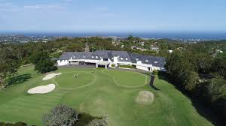
COST $85
Cheques: “Tenth Floor Limited” OR
Bank Transfer: Tenth Floor Limited BSB 082 053 Account 595406922
The fee includes for drinks and lunch with private chef in the club house.

RSVP Return the attached sheet with confirmation of payment to reception at Tenth Floor Wentworth Selborne Chambers 10/180 Phillip Street Sydney NSW marked to the attention of Manu Jaireth.

AWARDS
- Brian Beaumont Cup for the winner of the doubles round robin
- Susan Crennan Cup for the best and fairest female player as voted by the players

PARTNER Please nominate your partner or you will be allocated one.

ENQUIRIES Jane Buncle buncle@tenthfloor.org; Manu Jaireth jaireth@tenthfloor.org;

BENCH & BAR TENNIS 2022

Elanora Country Club

REGISTRATION FORM

Name_________________________________________________________

Member of Elanora Country Club: _______________(YES/NO)

Email Address _________________________________________________

Telephone Number _____________________________________

Preferred tennis partner

____________________________________________________________________

Cheque for $85 to ‘Tenth Floor Ltd’ attached

OR

I confirm direct transfer of $85 to:
Account Name: Tenth Floor Limited - BSB 082 053 Account 595406922

