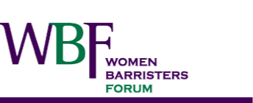

**WOMEN BARRISTERS FORUM Meeting**

**Held on Wednesday, 23 February 2022 by Zoom**

<https://us02web.zoom.us/j/81802613701?pwd=Nzd3d1pTdmFCYkJuYTNScWUrMnFqQT09>

Meeting ID: 818 0261 3701

Passcode: WBF2022

**AGENDA**

1. Apologies
2. Acceptance of previous minutes dated 17 November 2021
3. Chair’s Report - Naomi Sharp SC
4. Treasurer’s Report - Rosalind Winfield
5. Sub-committee Reports:
   1. Social and Networking - Elizabeth Picker, Caroline Dobraszczy and Anna Elizabeth
   2. Continuing Professional Development (CPD) - Claire Palmer and Claire Roberts
   3. Equitable Briefing - Ingrid King
   4. WLA Liaison Officer - Renée Bianchi
   5. Diversity and Equality Committee Liaison - Renée Bianchi
6. Bar Alumnae programme - Kerry Leotta
7. Janet Coombs lunch and video update - Madeleine Bridgett
8. Legal Aid and equitable briefing – Emily Graham
9. Research on women and charge out rates - Madeleine Bridgett
10. Bar Readers Course and Tutor Program - Catherine Hamilton-Jewel
11. Open Day for women law students - Catherine Hamilton-Jewel
12. Other business

Next meeting: