Not the NSW Bar Association
World Cup 2014 Tipping Competition

RULES

Entry Fee
$30 once off contribution. This, or a legally enforceable non-negotiable bill of exchange (‘IOU’) must be received with your first round tips which are due before 6am on Friday, 13 June 2014 (ie kick-off of the first game). Any IOU must be paid by 17 June 2014.

Prize pool distribution
60% to the winner, 30% to second place, 10% to third place but half of those prizes will be donated (on the prize-winner’s behalf) to the prize-winner’s nominated charity. In other words, half the money raised will go to charity. We are expecting a prize pool of over $3,000.

Tips
The form you must complete for the first round follows. Failure to tip any particular game or special category will not disqualify you, it will just reduce your chance of winning.
For the first round we will accept hard-copy entries by fax, DX or mail, although we strongly prefer an electronic copy of the document completed on screen and returned by reply email (to Ingmar’s address). The document is set up so you can ‘tab’ through to each field. Please do not add rows to the tables or otherwise alter the page breaks. The forms for the second and subsequent rounds will be sent by email and must be returned by reply email. Telephone tips will not be accepted.
The deadlines for later rounds are summarised on the last page of the form.
Cheques should be made payable to: ‘Ingmar Taylor Tipping Account’. But we prefer direct bank transfer:
Acc Name: Ingmar Taylor Tipping Account BSB: 062 099 Acc No: 10144203

In the ‘to account description’ type name of tipper.
Our contact details (please send the forms and any cheques to Ingmar at State Chambers)
Ingmar Taylor SC | State Chambers | Level 36, 52 Martin Place, Sydney 2000
T 9223 1522 | F 9223 7646 | DX 410 Sydney | ingmar.taylor@statechambers.net

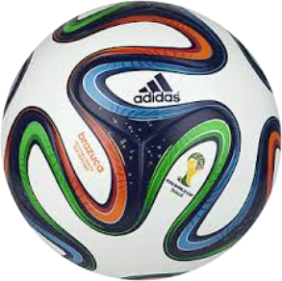
Mark Gibian | H B Higgins Chambers | Level 6, 82 Elizabeth St, Sydney 2000
T 9223 3633 | F 9232 1124 | DX 190 Sydney | gibian@hbhiggins.com.au

Small Print
This competition will be administered in the best traditions of the Bar. The interpretation of these rules, and any other decisions made by us as Game Masters, are fully challengeable before any court that will hear your claim. Correspondence will be entered into, and lengthy written submissions, preferably with extensive case references, are encouraged. Our relatives and the staff at Chambers are encouraged to play, although on past form have little chance of winning. The competition is open to Judges, Barristers and our friends. Had the NSW Bar Association been asked it would have categorically stated it has nothing to do with this competition.

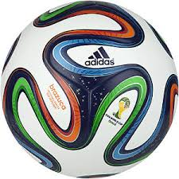

First Round Tipping Form

These tips must be in before 6am AEST 13 June 2014
You cannot tip this round in parts, the whole of this form (including the bonus point questions at the end of this form) must be made at the one time. Tipping forms for the later rounds will be emailed to you.
Your name:
Your organisation and address:
(DX please if you have it)

Your email address
(We will only communicate with you by email):
Your phone number and area code:
The charity you nominate to get the donation if you win - registered charities only:
The name of another tipper in the competition that you really want to beat (optional, and you can have more than one name):

First Round Games
To complete this part of the form, type into the middle columns the score that you tip. You will get 2 points for tipping the correct result (ie the winner or a draw) and 0.5 bonus points for tipping the correct score.
For example if you tip “Brazil 3 1 Croatia” you are tipping Brazil to win 3-1. If Brazil won 3-0 you would get 2 points for the correct result, but not the bonus 0.5 point for the correct score. If the actual result was Croatia winning 3-1 you get no points – you would not get the bonus point for tipping the correct score (even though you tipped a 3-1 result).
As a further example, if you tip “Brazil 1 1 Croatia” you are tipping a 1-1 draw. If the result is 2-2 then you again would get 2 points for the correct result (a draw) but not the bonus 0.5 point for the correct score.


Game | Date | Local time* | Team | Your tipped score |  | Team | Venue | Grp | Points
1 | 12.06.14 | 17:00 | 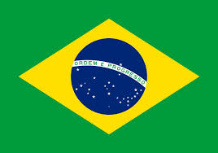 Brazil |  |  | 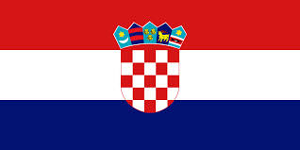 Croatia | Sao Paulo | A
2 | 13.06.14 | 13:00 | 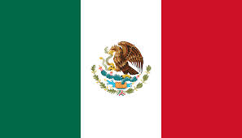 Mexico |  |  | 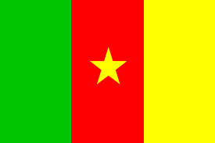 Cameroon | Natal | A
3 | 13.06.14 | 16:00 | 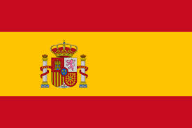 Spain |  |  | 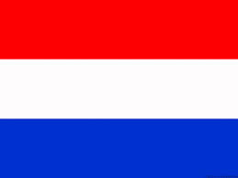 Netherlands | Salvador | B
4 | 13.06.14 | 18:00 |  Chile |  |  |  Australia | Cuiaba | B
5 | 14.06.14 | 13:00 | 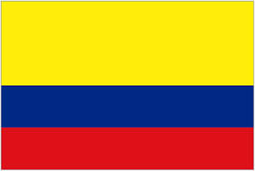 Colombia |  |  |  Greece | Belo Horizonte | C
6 | 14.06.14 | 22:00 |  Cote d’Ivoire |  |  | 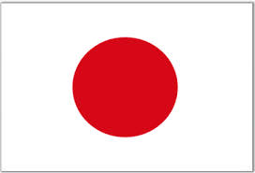 Japan | Recife | C
7 | 14.06.14 | 16:00 | 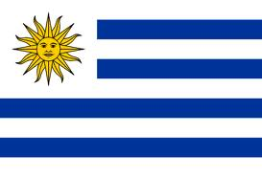 Uruguay |  |  | 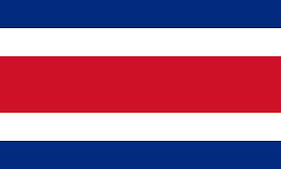 Costa Rica | Fortaleza | D
8 | 14.06.14 | 18:00 | 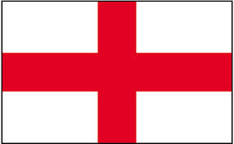 England |  |  |  Italy | Manaus | D
9 | 15.06.14 | 13:00 | 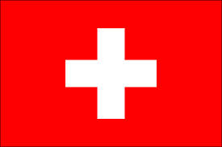 Switzerland |  |  | 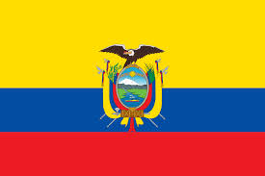 Ecuador | Brasilia | E
10 | 15.06.14 | 16:00 | 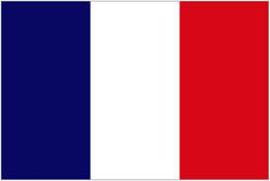 France |  |  | 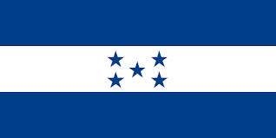 Honduras | Porto Alegre | E
11 | 15.06.14 | 19:00 | 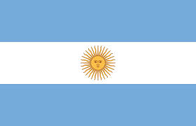 Argentina |  |  | 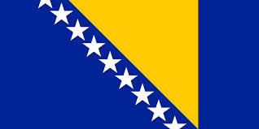 Bosnia-Herzegovina | Rio De Janeiro | F
12 | 16.06.14 | 16:00 |  Iran |  |  |  Nigeria | Curitiba | F
13 | 16.06.14 | 13:00 |  Germany |  |  | 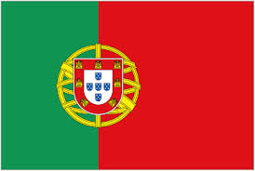 Portugal | Salvador | G
14 | 16.06.14 | 19:00 | 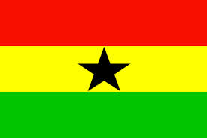 Ghana |  |  |  USA | Natal | G
15 | 17.06.14 | 13:00 | 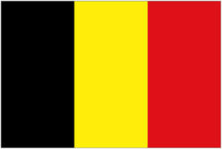 Belgium |  |  | 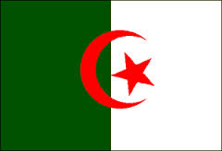 Algeria | Belo Horizonte | H
16 | 17.06.14 | 18:00 | 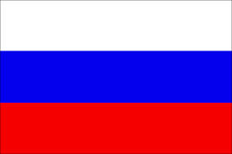 Russia |  |  |  Korea Republic | Cuiaba | H
17 | 17.06.14 | 16:00 | Brazil |  |  | Mexico | Fortaleza | A
18 | 18.06.14 | 18:00 | Cameroon |  |  | Croatia | Manaus | A
20 | 18.06.14 | 13:00 | Australia |  |  | Netherlands | Porto Alegre | B
19 | 18.06.14 | 16:00 | Spain |  |  | Chile | Rio De Janeiro | B
21 | 19.06.14 | 13:00 | Colombia |  |  | Cote d’Ivoire | Brasilia | C
22 | 19.06.14 | 19:00 | Japan |  |  | Greece | Natal | C
23 | 19.06.14 | 16:00 | Uruguay |  |  | England | Sao Paulo | D
24 | 20.06.14 | 13:00 | Italy |  |  | Costa Rica | Recife | D
25 | 20.06.14 | 16:00 | Switzerland |  |  | France | Salvador | E
26 | 20.06.14 | 19:00 | Honduras |  |  | Ecuador | Curitiba | E
27 | 21.06.14 | 13:00 | Argentina |  |  | Iran | Belo Horizonte | F
28 | 21.06.14 | 18:00 | Nigeria |  |  | Bosnia-Herzegovina | Cuiaba | F
29 | 21.06.14 | 16:00 | Germany |  |  | Ghana | Fortaleza | G
30 | 22.06.14 | 18:00 | USA |  |  | Portugal | Manaus | G
31 | 22.06.14 | 13:00 | Belgium |  |  | Russia | Rio de Janeiro | H
32 | 22.06.14 | 16:00 | Korea Republic |  |  | Algeria | Porto Alegre | H
33 | 23.06.14 | 17:00 | Cameroon |  |  | Brazil | Brasilia | A
34 | 23.06.14 | 17:00 | Croatia |  |  | Mexico | Recife | A
35 | 23.06.14 | 13:00 | Australia |  |  | Spain | Curitiba | B
36 | 23.06.14 | 13:00 | Netherlands |  |  | Chile | Sao Paulo | B
37 | 24.06.14 | 16:00 | Japan |  |  | Colombia | Cuiaba | C
38 | 24.06.14 | 17:00 | Greece |  |  | Cote d’Ivoire | Fortaleza | C
39 | 24.06.14 | 13:00 | Italy |  |  | Uruguay | Natal | D
40 | 24.06.14 | 13:00 | Costa Rica |  |  | England | Belo Horizonte | D
41 | 25.06.14 | 16:00 | Honduras |  |  | Switzerland | Manaus | E
42 | 25.06.14 | 17:00 | Ecuador |  |  | France | Rio de Janeiro | E
43 | 25.06.14 | 13:00 | Nigeria |  |  | Argentina | Porto Alegre | F
44 | 25.06.14 | 13:00 | Bosnia-Herzegovina |  |  | Iran | Salvador | F
45 | 26.06.14 | 13:00 | USA |  |  | Germany | Recife | G
46 | 26.06.14 | 13:00 | Portugal |  |  | Ghana | Brasilia | G
47 | 26.06.14 | 17:00 | Korea Republic |  |  | Belgium | Sao Paulo | H
48 | 26.06.14 | 17:00 | Algeria |  |  | Russia | Curitiba | H
*Note: for AEST add 13 hours, or 14 hours for games in Cuiaba and Manaus

Bonus Points
(This page must be submitted at the same time as your first round tips)
1. For 2 bonus points each, based only on the first round games, please type the team that:
Will score the most goals
Will score the least goals
Will concede the most goals
Will concede the least goals
Will receive the most cards (both red and yellow)

2. For 3 bonus points each, please type the name of the player who will:
Score the most goals in the whole tournament (ie the winner of the ‘golden boot’)
Be named by FIFA as the player of the tournament (ie the winner of the ‘golden ball’)

3. For 1.5 bonus points each please tip the 16 teams that will get through to the second round. Note, the 16 teams will be the top two teams from each of the 8 groups at the end of the first round. We have set out below all 32 teams. CHECK THE BOX of the two teams from each group that WILL GET THROUGH.
Group A | Group B | Group C | Group D | Group E | Group F | Group G | Group H
Brazil | Spain | Colombia | Uruguay | Switzerland | Argentina | Germany | Belgium
Croatia | Netherlands | Greece | Costa Rica | Ecuador | Bosnia-Herzegovina | Portugal | Algeria
Mexico | Chile | Cote d’lvoire | England | France | Iran | Ghana | Russia
Cameroon | Australia | Japan | Italy | Honduras | Nigeria | USA | Korea Republic

4. For 2 bonus points for each team you get correct please type in the table below the eight teams that will get to the quarter finals (ie the 3rd round).
Note: The teams that get through will be the teams that win the following matches:
Winner Group A plays Runner up Group B; Winner Group E plays Runner up Group F;
Winner Group B plays Runner up Group A; Winner Group F plays Runner up Group E;
Winner Group C plays Runner up Group D; Winner Group G plays Runner up H; and
Winner Group D plays Runner up Group C; Winner Group H plays Runner up G.

5. For 3 bonus points for each team you get correct please type in the table below the four teams that will get to the semi finals (ie the 4th round).

6. For 8 bonus points please type in the space below the team that will win the competition.

Later Rounds
Tipping forms for the second and subsequent rounds will be emailed to you. Because of the close proximity of the various rounds you will have to tip them in parts and have tips in quickly.
In the later rounds, you will get 4 points for tipping the team that goes through from each game (after penalties if necessary) plus 1 bonus point for tipping the correct score (before penalty shootout).
There will be bonus points for all games after first round (you tip these at start of 2nd round):
1. Tip one player and get 1 point for every goal he scores.
2. Tip one player and get 4 points each time he is sent off.
3. Tip the team that will get most red and yellow cards (3 points).
There will also be further bonus points for each game in the semis and finals:
1. Tip in which 15 minute block the first goal is scored (1 point).
2. Tip one player and get 1 point per goal he scores in that game.
For these later rounds we will send emails to you, but you might want to note the following tipping deadlines (all AEST):
1. 1st half of 2nd round: Form will be sent PM Wednesday, 25 June 2014 to be returned before 2am Sunday, 29 June 2014.
2. 2nd half of 2nd round: Form will be sent PM on Friday, 27 June 2014 to be returned before 2am on Tuesday, 1 July 2014.
3. Quarter finals: Form will be sent PM on Wednesday, 2 July 2014 to be returned before 6am Saturday, 5 July 2014.
4. Semi-finals: Form will be sent on Sunday, 6 July 2014 to be returned before 6am Wednesday, 9 July 2014.
5. Final and 3v4 playoff: Form will be sent PM on Thursday, 10 July 2014 and to be returned before 6am on Sunday, 13 July 2014.
You are permitted one default ‘forget to tip’ for the above five tipping rounds: on the first occasion you do not get your tips in (only) you will be deemed to have tipped the team with the lower FIFA ranking in each game (unless that results in a point score higher than the median for that round, in which case you get the median score).

Further information
The World Cup official website is fifa.com/worldcup
The SBS website (with details of the broadcast times and team profiles) is theworldgame.sbs.com.au

Prize pool distribution where more than one person ties for one or more of the first 3 places is as follows (note: in each case half of all winnings go to each prize-winner’s nominated charity). Where: - 2 people are equal first, then they get 90% of the prize pool each, and 10% of the pool goes to the next highest score, and if more than one person has the next highest score, that 10% is divided equally amongst them; - more than 2 people are equal first, then 100% of the prize pool is divided equally amongst them, with no other prizes awarded; - there is 1 winner, and 2 or more people on the next highest score, then the winner gets 60%, and those on the next highest score share equally 40% and no other prizes are awarded; - there is 1 winner, 1 in second place, and more than 1 person in equal third place, then the prizes are divided, 60% to 1st place, 30% to 2nd place, and the remaining 10% divided equally amongst those in equal third place.

